Are you Sitting Comfortably?
Did you know?
- Sickness absence from work currently costs the UK £14.3 billion.
- 8.9 million working days are lost.
- In 2019/20 biggest reason for sickness absence was back, neck and shoulder pain.
- In 2019/20 WRMSDs (work related musculoskeletal disorders) accounted for 30% of all work-related ill health
(Work related musculoskeletal disorder statistics (WRMSDs) in Great Britain, 2020)

We offer corporate care for your businesses, and provide rapid access to effective physiotherapy for your employees.

Benefits for you:
- Reduced employee absence
- Increased employee happiness and job satisfaction
- Reduced recurrence of the pain
- Increased Productivity
- Local on the Chineham Park, Basingstoke and close to Langston Technology Park, Havant so reduced travel time for employees
- Cost Saving

To find out more about our corporate services then please email us: enquiries@physio-logical.net or call 02394 350270 / 07835 712306

Here is a selection of exercises that you may find useful and we suggest you spend a few minutes several times a day completing these exercises.

If you are unsure of any exercises then please contact us or your doctor before you commence them.

Neck Side Flexion

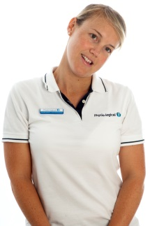 | - Tilt your head side to side  - Repeat five times to each way

Thoracic Spine Rotation

- Sitting
- Cross your arms over your chest and rotate round to the right and left five times then hold the last one each side for for 30 seconds

Thoracic Spine Extension

- Sitting
- Cross your arms over your chest and arch backwards
- Hold for 30 seconds

Thoracic Spine Flexion

- Sitting
- Cross your arms over your chest and drop your right shoulder down towards your hips
- Hold for 30 seconds

Thoracic Spine Side Flexion

- Sitting
- Cross your arms over your chest and drop your right shoulder down towards your right hip
- Hold for 30 seconds then repeat going to the left

Pectoral Stretch
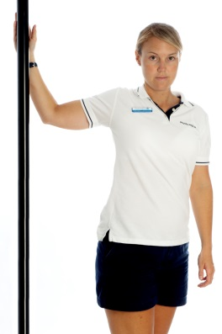 | - Stand at end of wall or in doorway  - Place inside of bent arm on surface of wall and position the bent elbow at shoulder height  - Walk forwards and turn body away from positioned arm.  - Hold for thirty seconds repeat twice

Shoulder Stretch (back)
- Standing, clasp your hands together and stretch your arms forwards until you can feel a stretch across the back of your shoulders and upper back
- Hold for thirty seconds

Shoulder Stretch (front)
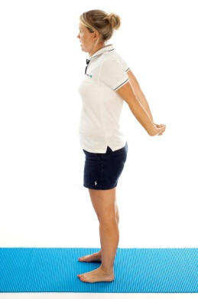 | - Standing, clasp your hands together and stretch your arms backwards until you can feel a stretch across the front of your shoulders and chest  - Hold for thirty seconds

Hip Flexor Stretch

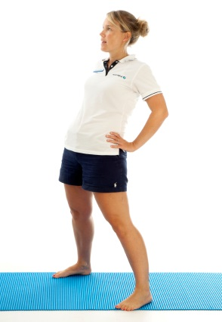 | - Stand lazy dropping your hips forward  - You should feel the stretch in the front of the hips.  - Hold for thirty seconds

ITB/TFL Stretch

- Cross one leg in front of the other one and bend that knee.
- Keep the back leg straight.
- Drop your hip of the back leg to the side.
- To increase the stretch lift the arm of the straight leg up and over.
- You should feel the stretch in the outer thigh/hip of the straight leg.
- Hold for thirty seconds, repeat each side

Tricep Stretch

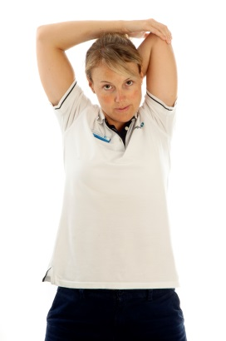 | - Reach down with your hand towards the middle of your shoulder blades  - Push your arm down further with your opposite hand  - You should feel the stretch in the muscle at the back of your upper arm  - Hold for thirty seconds, repeat each side

Please also remember to maintain health the recommendations for general exercise are:
≥150mins moderate aerobic exercise (cycle, brisk walk) + 2 strength sessions per week.
OR
≥75mins vigorous aerobic exercise (running/tennis) + 2 strength sessions per week
OR
≥A mix of both = 150mins + 2 strength sessions per week.
If you are suffering from any aches and pains then we can help you today. To book to see one of our expert physiotherapists then please email us: enquiries@physio-logical.net, call 02394 350270 / 07835 712306 or book online.

